Electrical Automation Technology, Control Systems Technology & Electrical Design Systems Technology
Performance Test #3, Single-Pole Switches and Receptacles

Name ______________________________ Instructor Verification __________ Grade ____________

Materials:
Materials Provided by You | Materials Provided by the Department
1. Necessary Tools | 1. Single pole Switch
2. NM-B or MC Cable | 2. Split Duplex Receptacle
3. Wire Kit

Objective:
Given necessary materials, the student will construct an electrical circuit in 45 minutes, as evidenced by scoring a minimum of 75% on this performance test.

Time Limit:
You are allowed 45 minutes to complete the circuit. Five points for every five minutes over the allotted time will be deducted from the score. The maximum overtime allowed is fifteen minutes.

Description of the Circuit:
Construct a circuit in which power is fed to a switch box. There is a single pole switch that controls the top half of the receptacle. The bottom half of the receptacle is “hot” at all times. The switch and the duplex receptacle are installed in metal boxes. This circuit is to be completed within a 45 minute time limit.

Part 1 (+20 points):
Using a straight edge, draw how this circuit will be wired.
Start Time__________ Finish Time__________

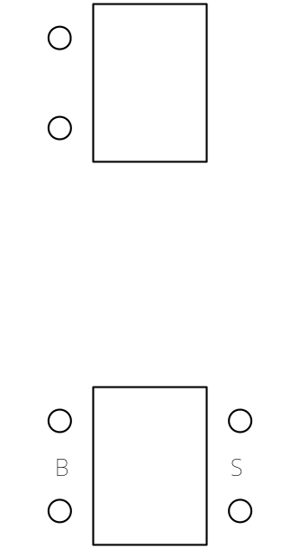
Performance Test #3

Part #2 (+80 points):

Construct the circuit.

__________ Circuit wired to the NEC and fitting tight. +10 points

__________ 6” of free conductor from the edge of the box. +10 points

__________ Wire nut connections secure. +10 points

________ Conductors on devices correctly. +10 points

__________ 1/4” of cable sheath inside box. +10 points (if NM-B is used)

__________ All anti-short bushings in place. +10 points (if MC is used)

__________ Circuit works as described. +30 points (troubleshooting yourself +15 points)

